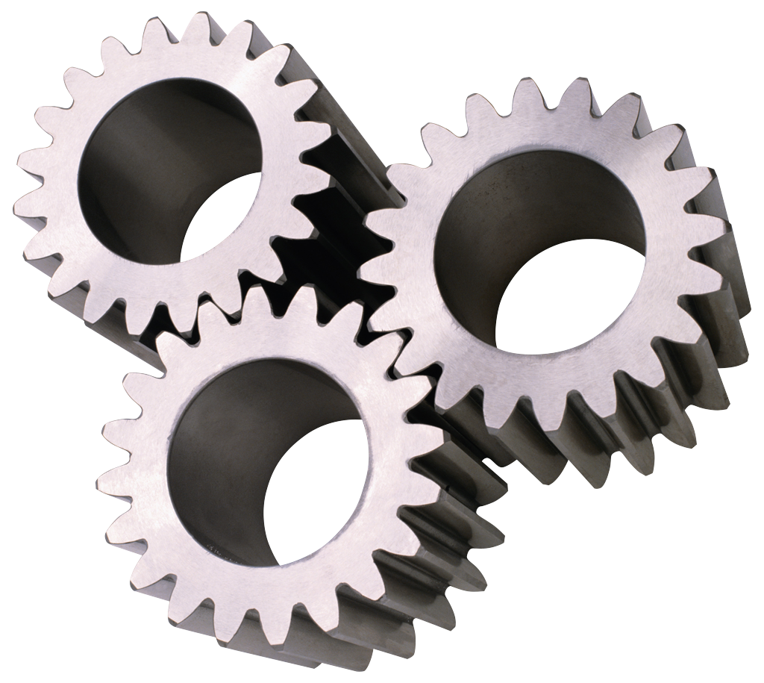

Semester #2: Science

01/31/14

You can always email me at sjlewis@k12albemalre.org

No internet access at home, or prefer a paper copy? If you would like paper copies future newsletters, please sign here, and have your child return to school.

______________________________

We have had a rough start to the science semester, as snow days thwart our attempts at consistency. However, we have managed to …

Give syllabi

Have Safety Contract Signed (please sign your child’s if they have not turned it in)

Do our first Lab (Ask your child about the Hot Wheels)!

And

Explore Mystery Cookies!

Next we will move into our unit on Matter!

## Unit #1: The Nature of Science

Please post any comments, questions, or concerns, on the class blog at [www.burleymath6.weebly.com](http://www.burleymath6.weebly.com)

Click on more and then science blog!

Let Me Know

A newsletter from Mrs. Jones-Lewis

Science

6th Grade

[Street Address]  
[City], [State][Postal Code]

[Web Address]

Lorem Ipsum